Position Management (views)
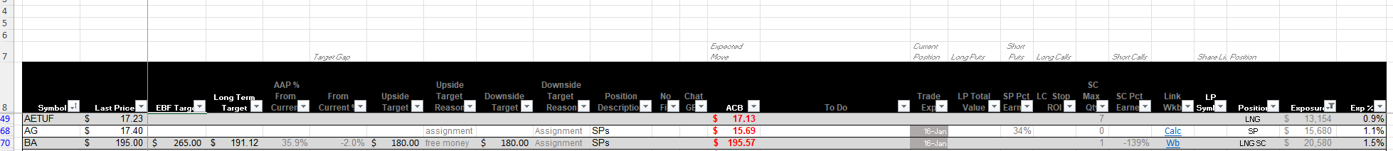
View: All Active Positions
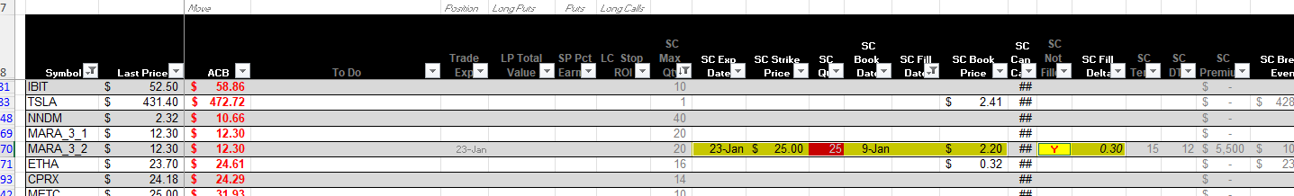
View: Covered Calls Available to Sell (MARA 3.2 is an unfilled bid, and has an error)

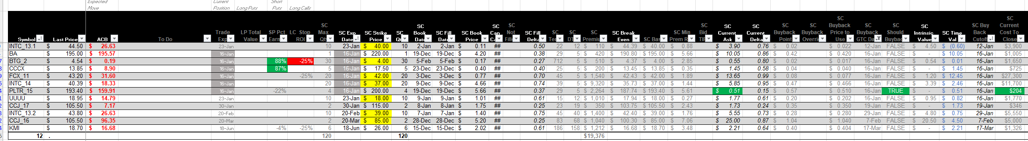View: Open Short Calls
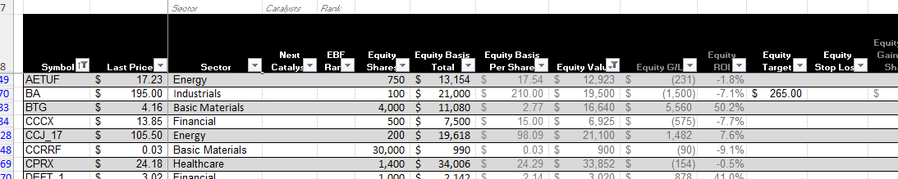
View: Equity
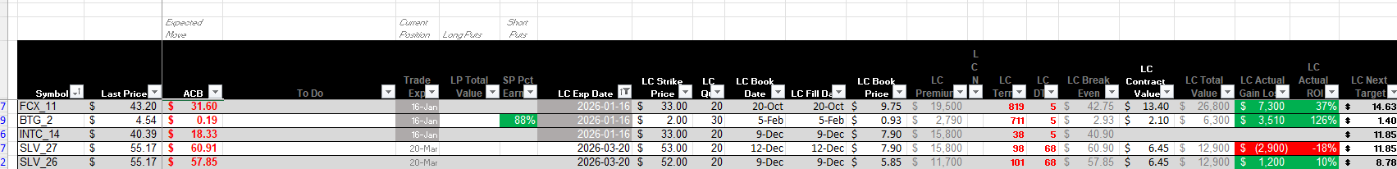
View: Long Calls / Puts

View: Open Short Puts
More re: Short Put management
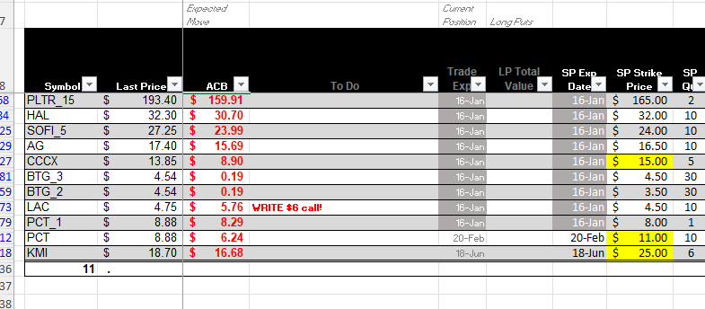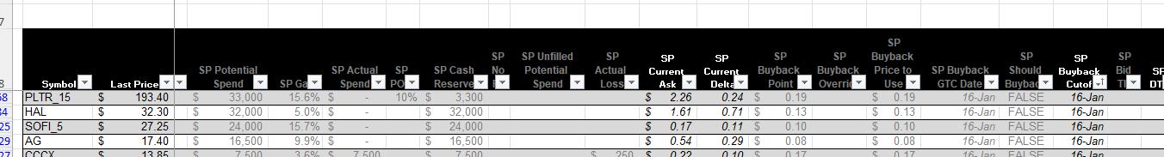
- What would assignment ACB be?
- What is expiring this week (highlighting in gray)
- What Action to take (let it expire worthless, roll out, etc.) in the To Do column (usually complete on Wednesday)
- Potential spend (calculated) / likelihood of assignment (manually assigned %)
- Current ask / Delta
- Buyback cutoffs (besides obvious expiration date, system calculates “Should Buyback” based on current cost and DTE, turns green if yes)
- Summary of cash available is below table, as is total potential spend, likely potential spend
MARA questions /answers
- Bid / ask spread and strike availability is manually (the current system does NOT access real-time or even delayed data; the new one will)
- The error display was an attempt to write more contracts that would be covered without being naked short
Trade log questions /answers
- There is a field for commentary, and even a link to a word doc
  - In practice the ‘Source’ and ‘Trigger’ are meant to quickly convey motivation for the trade
  - Every position has an associated Word doc with convention “ticker Latest.doc” (ie, PLTR Latest). That is where charts, news, summaries, and articles are kept)
- The error display was an attempt to write more contracts that would be covered without being naked short
- Current wheel trade handling
  - If Expires worthless, close the trade (start a new one if still interested in the underlying)
  - If assigned or rolled, add line items to the trade

